REPORT

CREDIT CARD FRAUD DETECTION USING MACHINE LEARNING

PROBLEM ID : 12

STUDENT NAME – SNEHAL PUNDIR
UNIVERSITY ROLL NO. - 2028860
SECTION – L

STUDENT NAME – KOMAL JOSHI
UNIVERSITY ROLL NO. - 2028746
SECTION – L

STUDENT NAME – SAPNA YADAV
UNIVERSITY ROLL NO. - 2028840
SECTION – L

PROBLEM DESCRIPTION:
In today’s digital time, most of the people use credit cards or debit cards for different purposes like online shopping, paying bills, booking tickets, etc. This makes the work easy and fast, but at the same time it also increases the chances of fraud. Fraud means when someone uses the card details without permission and makes transactions. In our dataset, there are different columns such as transaction id, amount, time, merchant type, transaction frequency and class. The class column tells whether the transaction is legitimate [normal](0) or fraudulent [fraud](1).
In this project, we are trying to solve this problem using machine learning techniques. We will build a system which can analyse the transaction data and predict whether a transaction is fraud or not. First, we will clean the dataset by checking missing values, removing duplicates and doing normalization wherever required.
Then, we will apply different machine learning algorithms such as Logistic Regression, KNN and SVM. After training the models, we will test them and evaluate their performance using different metrics to get better and more accurate results.

STEPS OF IMPLEMETATION:
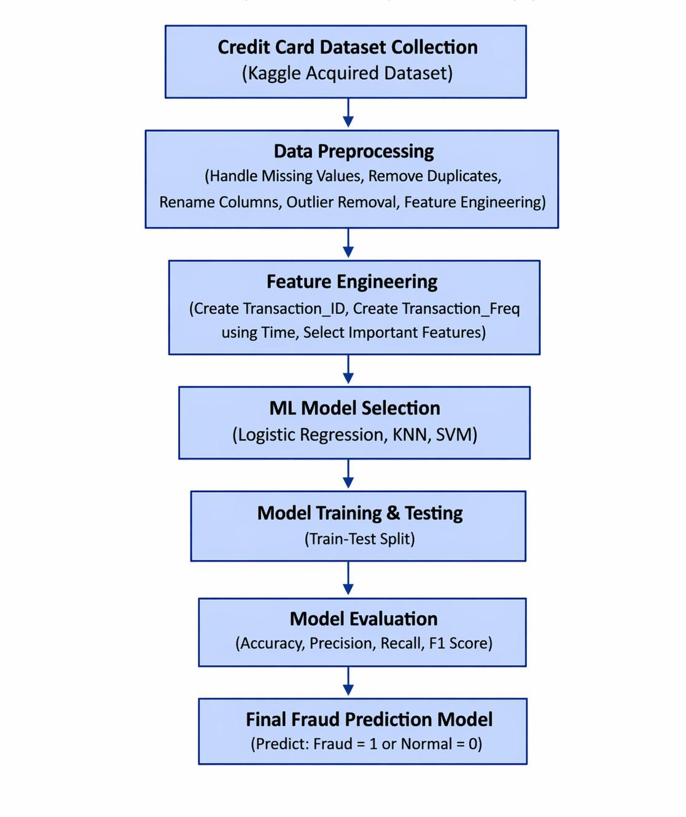
STEPS OF PREPROCESSING:
1. Data Preprocessing:
a) Selecting Required Data (Row Reduction):
From the large dataset, only the first 12,000 rows are selected using the head() function. This helps in reducing computational complexity and makes processing faster.

b) Column Renaming: The dataset columns are renamed to meaningful names for better understanding
- step → Time
- amount → Amount
- type → Transaction_Type
- isFraud → Class

c) Handling Missing Values:
Missing values in numerical columns are filled using the median of each column using the fillna() function. This helps in maintaining data consistency and avoids errors during processing.

d) Removing Duplicate Rows:
Duplicate rows are removed using the drop_duplicates() function to avoid repetition and ensure better data quality.

e) Outlier Detection and Removal:
Outliers in the Amount column are detected using the Interquartile Range (IQR) method. Values outside the range (Q1 − 1.5 × IQR) and (Q3 + 1.5 × IQR) are removed to improve data quality, model performance and reduce noise.

2. Feature Engineering:

a) Transaction ID Creation:
A new column Transaction_ID is created using sequential numbering to uniquely identify each transaction.

b) Transaction Frequency Creation:
A new feature Transaction_Freq is created based on the number of transactions occurring at the same time using grouping operation. The values are scaled down using simple division to keep them in a smaller range.

c) Selection of Relevant Features:
Only important columns are selected for the final dataset:
Transaction_ID, Time, Amount, Transaction_Type, Transaction_Freq, and Class.

d) Handling Inconsistent Values:
Text values in the Transaction_Type column were first standardized by converting them into a uniform format using uppercase letters and removing extra spaces. This helps in maintaining consistency in categorical data.

e) Label Encoding:
Since machine learning algorithms require numerical input, the categorical Transaction_Type column was converted into numeric values using Label Encoder. For example, PAYMENT, TRANSFER, CASH_OUT etc. were assigned unique numerical labels.

f) Feature Scaling / Standardization:
Numerical features such as Time, Amount and Transaction_Freq were standardized using StandardScaler. This transforms the values into a common scale with mean 0 and standard deviation 1, which improves model performance especially for KNN and SVM.

g) Principal Component Analysis (PCA):
PCA was applied after scaling to reduce dimensionality and remove redundant information from the dataset. It converts original features into principal components while preserving maximum variance. In this project, two principal components were selected for model training and visualization.

h) Selection of Final ML Ready Dataset:
After preprocessing, the final dataset contained only clean numerical values without missing data or text values. This dataset became suitable for applying machine learning classification algorithms.

IMPLEMENTATIONS:
After completing data preprocessing, feature scaling and PCA, three machine learning classification models were applied on the final ML-ready dataset to predict whether a transaction is Fraud (1) or Non-Fraud (0).
The dataset was divided into 70% training data and 30% testing data using train_test_split(). Training data was used to train the models and testing data was used to check their performance on unseen records.

Since the dataset contains more non-fraud transactions than fraud transactions, proper evaluation metrics were used to compare model performance.
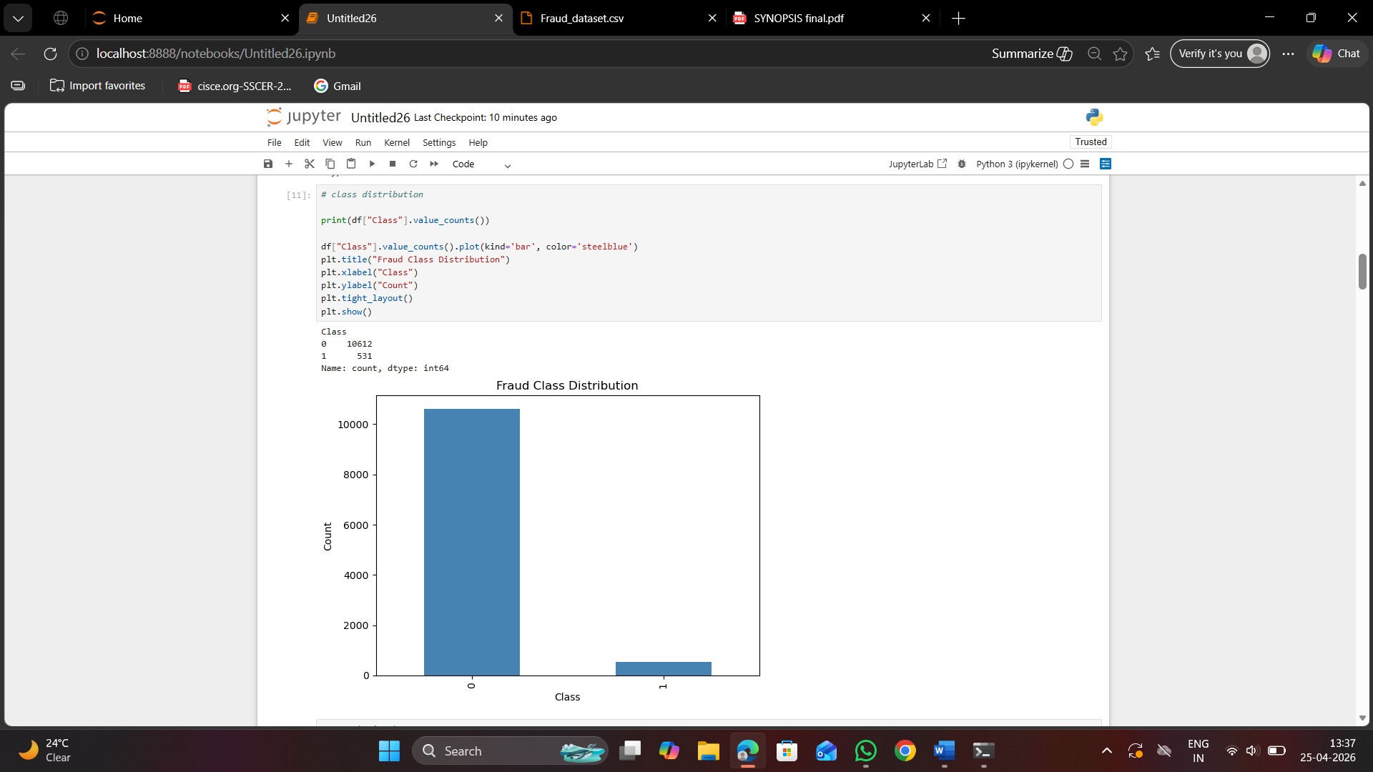

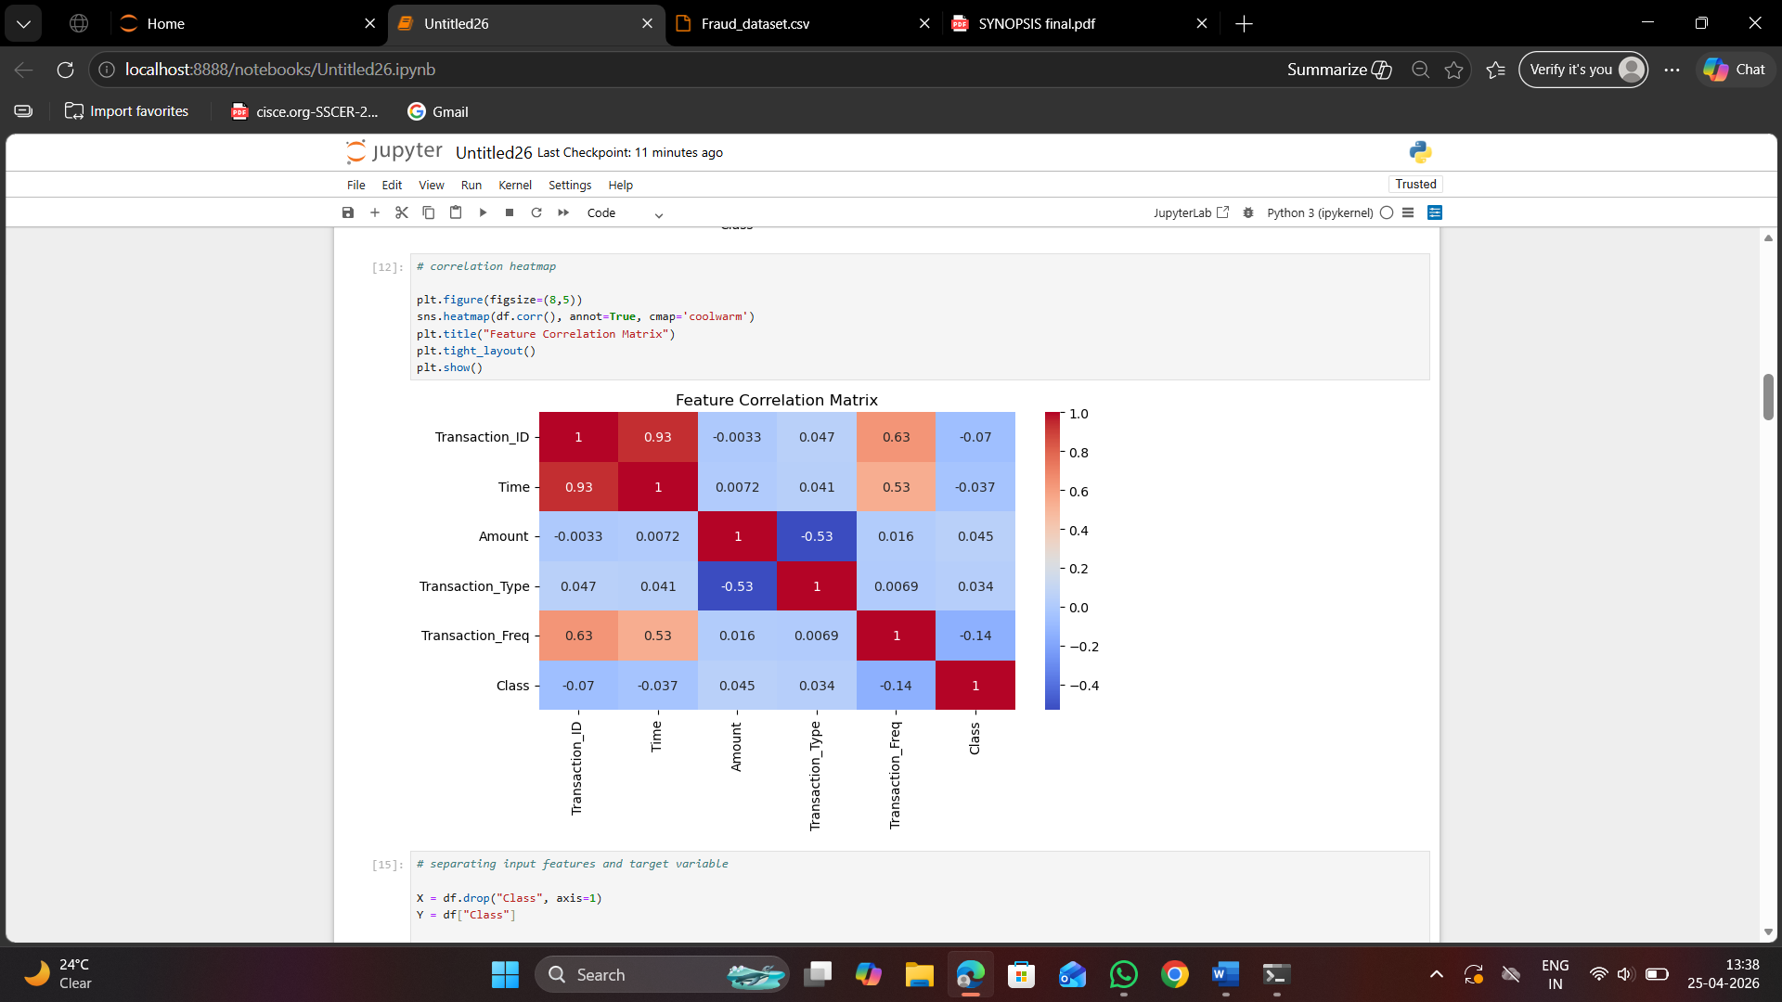

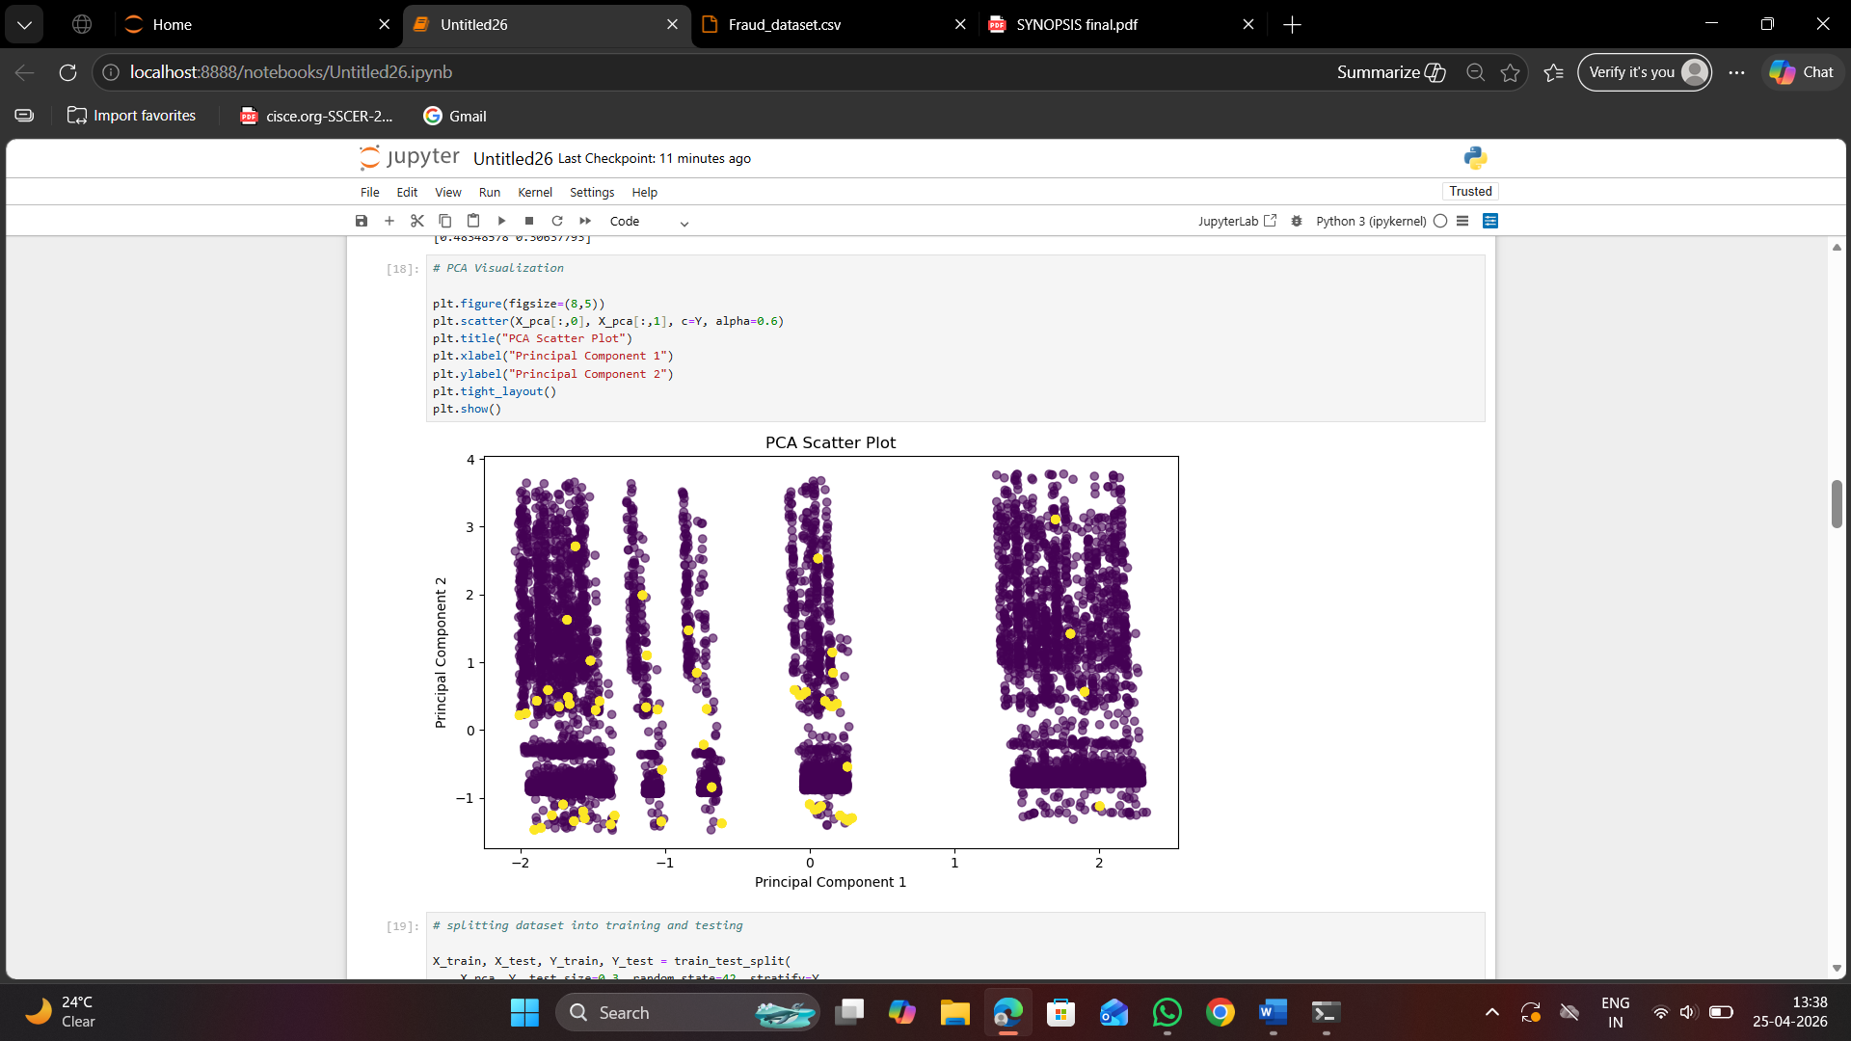
a) Logistic Regression
Logistic Regression is a supervised machine learning algorithm used for binary classification problems. It predicts the probability of two output classes such as fraud or non-fraud.
In this project, Logistic Regression was applied to classify transactions based on input features.
Parameter Used:
max_iter = 1000
Working:
The model learns the relationship between input features and target values during training and then predicts whether a transaction is fraud or genuine.

Result:
Accuracy = 95.24%
Precision = 0.00
Recall = 0.00
F1-Score = 0.00

Observation:
The model gave good overall accuracy because most transactions were non-fraud, but it failed to detect fraud transactions correctly. Therefore, it was not suitable as the final model.
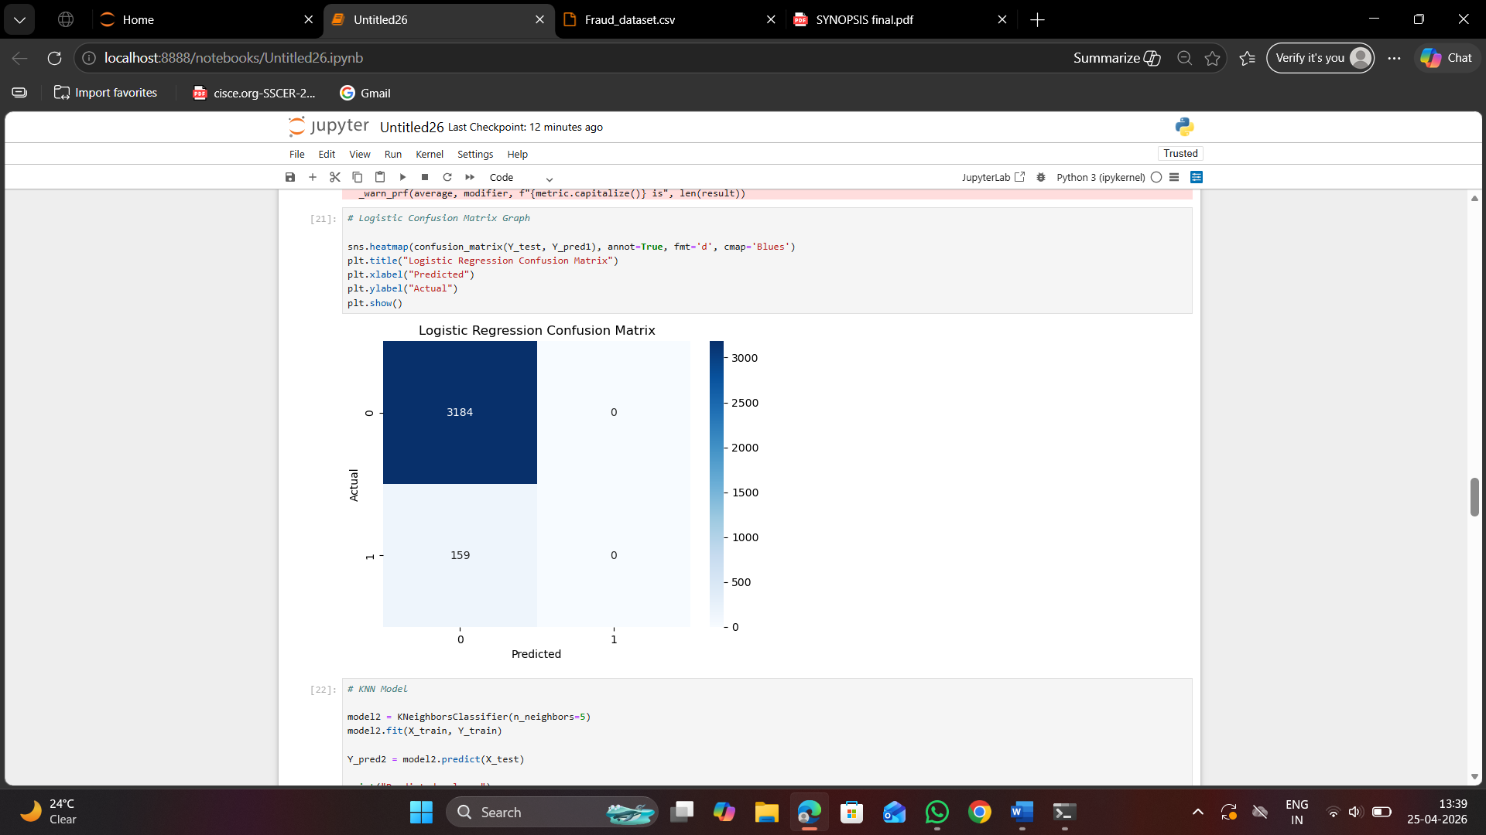
b) K-Nearest Neighbours (KNN):
KNN is a supervised classification algorithm that predicts output based on nearest similar data points. It checks nearby transactions and gives prediction according to majority class.
In this project, KNN was used to compare new transactions with previous similar transactions.
Parameter Used:
n_neighbors = 5
Working:
When a new transaction is given, the model checks the nearest 5 transactions and predicts fraud or non-fraud based on similarity.
Result:
Accuracy = 98.50%
Precision = 76.08%
Recall = 100%
F1-Score = 86.41
Observation:
KNN gave the best results among all models. It detected all fraud transactions correctly and also maintained very high overall accuracy. It performed better than Logistic Regression and SVM.
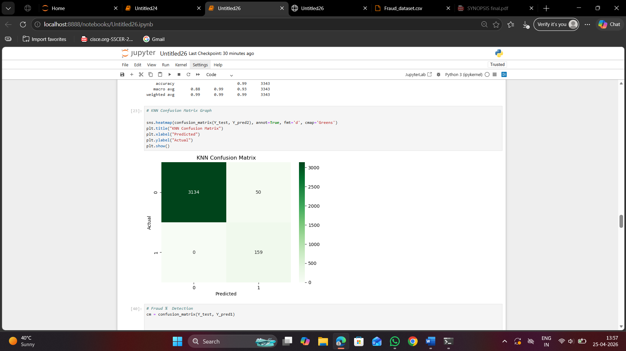
c) Support Vector Machine (SVM):
SVM is a supervised classification algorithm used to separate two classes by creating the best decision boundary between them.
In this project, SVM was used to classify fraud and non-fraud transactions.
Parameter Used:
kernel = 'rbf'
Working:
The model creates an optimal boundary line between both classes and predicts the class of new transactions.
Result:
Accuracy = 95.39%
Precision = 69.23%
Recall = 5.66%
F1-Score = 10.46%
Observation:
SVM gave good overall accuracy, but fraud detection was low compared to KNN. Therefore, it was not selected as the final model.
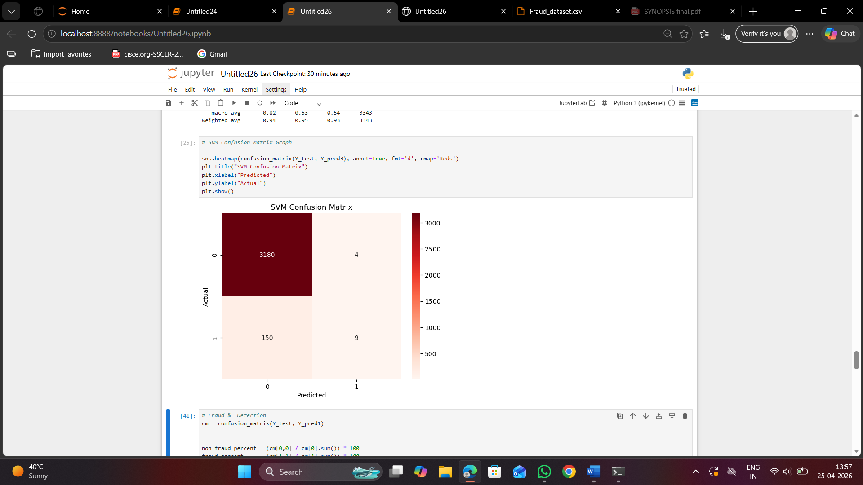

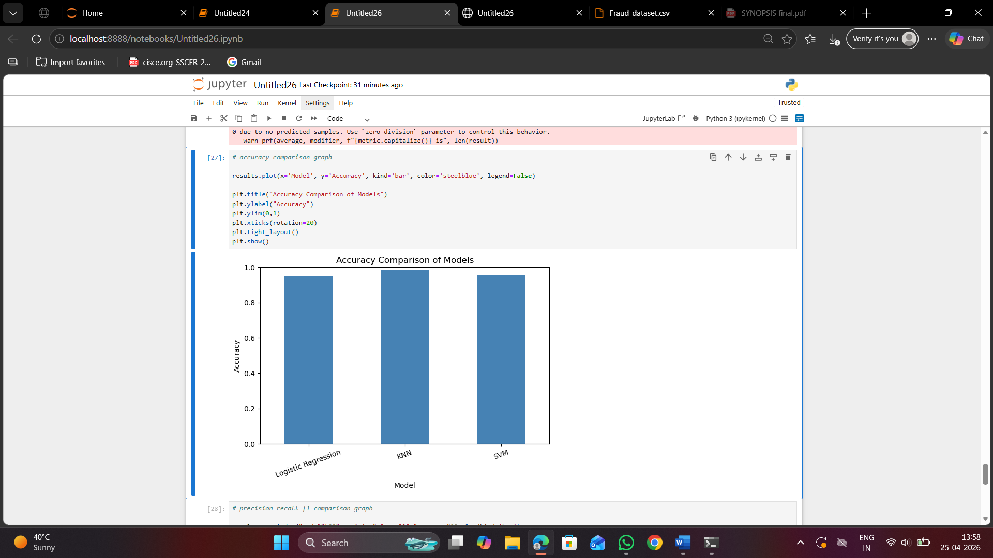
d). Techniques and Parameters Used:
- To improve model performance, the following techniques were used before training:
- Missing values were checked and handled.
- Duplicate rows were removed.
- Categorical values were converted into numeric form using Label Encoding.
- StandardScaler was used for feature scaling.
- PCA with 2 components was applied for dimensionality reduction.
- Train-test split ratio used was 70:30.
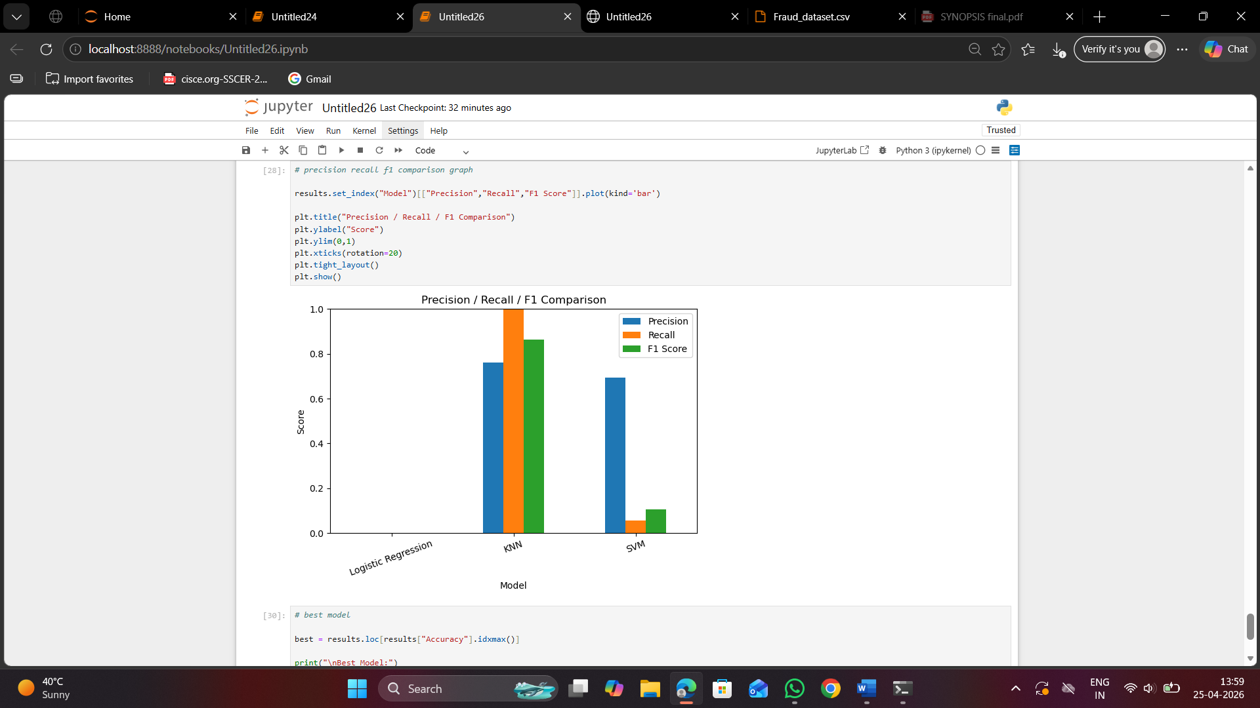
6. Final Model Comparison:

Model Accuracy Precision Recall F1-Score

Logistic Regression 95.24% 0.00 0.00 0.00
KNN 98.50% 76.08% 100% 86.41%
SVM 95.39% 69.23% 5.66% 10.46%

---

7. Best Model Selected:

After comparing all three models, KNN was selected as the best model because:

Highest Accuracy = 98.50%

Highest Recall = 100%

Best F1-Score = 86.41%

Better fraud detection than other models

KNN successfully identified fraud transactions more accurately than Logistic Regression and SVM.

---

8. Final Conclusion:

This project successfully used machine learning techniques for credit card fraud detection. Three models were trained and tested on the final dataset. After comparing their results, KNN performed best and gave the most accurate and reliable results. Therefore, KNN was selected as the final model for this project.

EXPECTED MODULES/LIBRARIES TO BE USED:
1. Pandas: The Pandas library in Python is primarily used for high-performance data manipulation and analysis, utilizing Series and DataFrames to manage structured data. In this project, it is used to load the dataset, select required rows, handle missing values, remove duplicates, and perform preprocessing operations.

2. NumPy: NumPy is primarily used for array processing, linear algebra, and statistical analysis, and acts as the foundational package for data science libraries like Pandas and Scikit-learn. It supports numerical computations required during data preprocessing.

3. Matplotlib / Seaborn: Matplotlib is an open-source Python library used for creating visualizations like histograms and boxplots to understand data distribution and detect outliers. Seaborn is built on Matplotlib and is used for creating more advanced statistical visualizations, though basic plots are mainly used in this project.

4. Scikit-learn (sklearn):
Scikit-learn is used for implementing machine learning algorithms like Logistic Regression, KNN, and SVM. It also provides tools for data splitting and evaluation metrics for model performance.

5. Label Encoder (sklearn.preprocessing): Label Encoder is used to convert categorical data such as transaction types into numerical form so that machine learning models can process them.

6. Train test split (sklearn.model_selection): This module is used to split the dataset into training and testing sets, which helps in validating the performance of the machine learning model.

7. Metrics (sklearn.metrics): Metrics are used to evaluate model performance using measures such as accuracy, precision, recall, F1-score, and confusion matrix.

8. Datetime (Pandas datetime functions): Datetime functions can be used to extract time-based features if required. In this dataset, the Time column is already in numerical format and used directly for analysis.

9. Custom Functions: User-defined logic is applied for tasks such as outlier removal using the IQR method and creation of new features like transaction frequency.

EXPECTED EVALUATION METRICS AND PLOTS TO BE USED:
1.Accuracy : It is used in machine learning that measures the proportion of correct predictions (both true positives and true negatives) out of the total number of predictions made.
Accuracy formula = (Correct predictions) / (Total predictions).

2. Precision: It measures the accuracy of positive predictions, calculated as the ratio of true positives to all predicted positives
Precision formula = TP / (TP + FP).
Where:
TP = True Positive. , TN = True Negative
FP = False Positive. , FN = False Negative

3. Recall (Sensitivity): It measures the ability of the model to correctly identify all positive instances.
Recall formula= TP / (TP + FN).

4. F1-Score: It is used for calculating the harmonic mean of precision and recall.
F1-score formula = 2 × (Precision × Recall) / (Precision + Recall).

5. Confusion Matrix: A confusion matrix is a table showing actual vs predicted values (TP, TN, FP, FN). It helps visualize model performance and types of errors.
Predicted Positive Predicted Negative
Actual Positive TP (True Positive) FN (False Negative)
Actual Negative FP (False Positive) TN (True Negative)

PLOTS REQUIRED:
1.Class Distribution Plot
- Shows the number of fraud vs non-fraud transactions.
- Helps identify data imbalance, which is common in fraud datasets.
2.Correlation Heatmap
- Displays relationships between features using colors.
- Helps in identifying which features are strongly relatedand useful for fraud detection.
3.Feature Distribution (Histogram/Boxplot)
- Shows how values of features are spread.
- Used to visualize the distribution of numerical features such as transaction amount.
4.Boxplot
- Used to detect outliers in the Amount column.
- It helps in visualizing extreme values and comparing the data before and after outlier removal

REQUIRED TOPICS FROM THE SUBJECT:
- Python Programming
Python is used as the main programming language for implementing the machine learning pipeline such as data preprocessing, feature engineering, and preparing the dataset for fraud detection.

- Data Structures
Data structures like arrays and DataFrames are used to store and handle transaction data efficiently. Pandas DataFrame is mainly used for managing and manipulating the dataset.

- File Handling
File handling is used to read the dataset from CSV files and store the processed dataset after preprocessing using functions like read_csv() and to_csv().

- Functions
Built-in functions are used for tasks like handling missing values, removing duplicates, and calculating transaction frequency. These functions help in simplifying and organizing the code.

- Conditional Statements
Conditional statements are used while filtering data, such as selecting fraud transactions and applying conditions during preprocessing steps like outlier removal.

- Loops
Loops are used for performing repetitive operations on the dataset, such as applying preprocessing steps on columns when required.

- Machine Learning Concepts
Concepts like classification are used to identify whether a transaction is fraudulent or not. Models like Logistic Regression, KNN, and SVM are applied for prediction.

- Data Visualization
Visualization techniques are used to understand data distribution and detect patterns using plots like histogram, boxplot, and correlation heatmap.

PLATFORM REQUIRED:
Jupyter Notebook: An interactive development environment used to write and execute Python code. It allows easy visualization, testing, and step-by-step implementation of machine learning models.

BOOKS AND LINK SOURCES:
- https://www.kaggle.com
Used for downloading the Credit Card Fraud Detection Dataset.

- https://scikit-learn.org
Official documentation for machine learning algorithms.
Hands-On Machine Learning with Scikit-Learn (reference book)

- https://pandas.pydata.org
Refrence for data preprocessing using Pandas.

- https://www.geeksforgeeks.org
For basic concepts and examples.

- https://matplotlib.org
Used for understanding data visualization techniques.

